Project Report
On
iSchool (E-Learning Management System)

Created By
DEEP R. HARIYANI
BCA-6

Under The Guidance of
PROF. BRIJESH MARU

Submitted To
GEETANAJALI COLLEGE OF COMPUTER SCIENCE & COMMERCE


Affiliated To
SAURASTRA UNIVERSITY

For Academic Year
2025-26

Abstract
iSchool (E-Learning Management System) is a project which aims in developing an online application to provide Online Education, maintain Study Materials, keep Student records and collect Payments. This project has login features, Educator as Admin and Student as an user can login into their own portal separately. The Admin can login, through which the admin can monitor the whole system. This System can be used to search for course, add new courses, edit course, check payment status etc. The Admin after logging into his account can generate reports such as sell Report. The User can login into his account to follow course he purchased and can share his/her feedback.
Overall this project of ours is being developed to help the Educator (Admin) as well as Students (User) to provide Teaching-Learning platform in the best way possible.

Acknowledgment
It is a genuine pleasure to express my profound gratitude and deep regards to my guide "PROF. BRIJESH MARU" for his exemplary guidance, monitoring and constant encouragement. I would like to express my special thanks to GEETANAJALI COLLEGE OF COMPUTER SCIENCE & COMMERCE who gave me the golden opportunity to do this wonderful project on the topic "iSchool(E-Learning Management System)", which helped me in doing a lot of research and i came to know about so many new things.

INDEX
Chapter 1: Introduction……………………………………..………………………………..……………. 6
  - Overview……………………………………………………………….………………….…….. 7
  - Objectives……………………………………………………………………………………..… 8
Chapter 2: System Analysis………………………….………………………………..………………….. 9
2.1 Identification of Need…………….………………………......…………………… 10
2.2 Software Requirements Specification (SRS)………….…..……………... 10
2.2.1 Data Gathering……………………………………….…………..………… 11
2.2.2 Feasibility Study...………………………………………..………..……... 12
2.2.3 Software Process Model…………………….……….………………... 13
2.3 Data Flow Diagrams (DFD)…………………………..……………………………. 16
2.3.1 DFD 0 Level…………………………………………….………………..….. 16
2.3.2 DFD 1 Level…………………………………………………………………… 17
2.3.3 DFD 2 Level…………………………………………………………………… 18
2.4 Entity Relationship Diagram (ER-Diagram)……………………………….. 19
2.5 Flow Chart……………………………………………………………………………….. 20
2.6 Gantt Chart……………………………………………………..….……………..……. 23
2.7 Class Diagram………………………………………………..……………..…………. 24
Chapter 3: System Design…………………………………………………………………….……...…. 25
3.1 Input Module………………………………………………………….…………….…. 25
3.2 Output Module…….……………………………………………………………….…. 26
3.3 Modularization Detail………………………………………………………….…… 26
3.4 Process Logic……………………………………………………………….…………… 27
3.5 Data Integrity………………………………………………….……………………….. 31
3.6 Data Dictionary……………………………………………..………………………... 32
3.7 User Interface Design……………………………………………………….……… 38
Chapter 4: Tool and Environment…………………………………………………..……..……..… 39
4.1 Hardware Requirements……………………………………..………….……. 39
4.2 Software Requirements……………………………………….…………..…… 39
Chapter 5: Testing………………………………………………………………………………………… 40
7.1 Type of Testing……………………………………………….………………….…. 41
7.2 Use Case……………………………………………………….…………………….… 43
7.3 Test Cases……………………………………………………………..……….……… 46
Chapter 6:Sanpshots……………………………………………………………………………………… 48
Chapter 6: Implementation…………………………………………………..………………………. 68

Chapter 7: Limitations………………………………………………………………………………...... 69
Chapter 8: Future Scope…………………………………………………………….………………….. 70
Chapter 9: Conclusion..………………………………………………………………………………….. 71
Bibliography…………………………………………………………………………..………………………. 72

- Introduction


The use of e-Learning technology in higher education institutions is no longer an option but has become a necessity. In an era known as the society of technology and knowledge, where lifelong learning is a way of life, it is important that educational institutions have as a priority the goal of finding effective ways of providing new learning opportunities according to their environment, student characteristics, teacher training, economic crisis and advancing technology in an effort to make learning more efficient, equitable and innovative in higher education.
Normally it has been practised in higher education and corporate and occupational training contexts as a part of lifelong learning. However, with the emergence of new open and mobile platforms and web apps, a range of possibilities has opened to facilitate teaching and learning processes in fully on-site or blended environments. As a result, e-learning has been implemented in all educational systems, transcending the traditional idea of distance education.

.

  - Overview

It is difficult to find time for the training necessary to gain new skills and boost your productivity. With iSchool you’re able to learn at a pace that is comfortable for you. iSchool is a powerful Learning Management System implementing the latest trends in e-learning. E-Learning is learning utilizing electronic technologies to access educational curriculum outside of a traditional classroom. In most cases, it refers to a course, or program delivered completely online. We define eLearning as courses that are specifically delivered via the internet to somewhere other than the classroom where the professor is teaching. E-Learning has been proven to be a successful method of training and education is becoming a way of life for many citizens in India and across the World. iSchool Publisher is a professional team development environment for the rapid development of e-courses by their own.
Any Person who wants to gain new skills can join iSchool. A Person/Student/Learner has to fill up registration form which is absolutely Free. Once Learner registers successfully, they will get UserID/Email and Password for login into Student/Learner Panel. After login they can buy any course as per their choice or requirement which is available in iSchool. They can watch purchased video courses online and can submit their feedback. As well they can update their profile and can change password. Admin of this system will upload new courses which will be available for everyone. Admin can delete or edit student/learner details. Admin can modify course details and can check sells report.

  - Objectives

A flexible web-based learning experience allows you to go through a guided curriculum or choose lessons on an as-needed basis. Following are the main objectives:-
- Ability to recall previously learned material – Students/learners can watch video courses as many times as they need. If they forgot something during the course they can come back and watch that specific part anytime.
- Creative way to present lesson – It is very creative way to present lectures. It will surely enhance teaching ability of tutor.
- Low Cost – As nobody needs to travel or rent anything so it’s very cost efficient.
- High Quality – As tutor do not has time boundation so he can teach in his own comfort time.
- Learn anytime from anywhere – Students/Learners can start learning anytime from anywhere they just required internet connection with a compatible device.
- Improve course quality according to learner’s feedback – Tutor can improve their course as per student’s feedback. It will help tutor to improve their ability to teach.
Earn Money Online– As courses are paid so we can say it’s an online teaching business which has no boundaries means students/learners can join from across the world so this system can make good business with good quality.

- System Analysis

System Analysis is the process of studying a procedure in order to identify its goals and purposes and create systems and procedures that will achieve them in an efficient way. It is a problem solving technique that improves the system and ensures that all the components of the system work efficiently to accomplish their purpose.
A systems analyst researches problem, plans solutions, recommends software and systems, and coordinates development to meet business or other requirements. The main goal of this system analyst is to collect different data from different site, process these data and generate progress as well as daily report.
System analyst operates in a dynamic environment where change is a way of life. The environment may be a business firm, a business application, or a computer system. to construct a system the following key elements must be considered: -
Input: Input is what data the system receives to produce a certain output.
Output: What goes out from the system after being processed is known as Output.
Processing: The process involved to transform input into output is known as Processing.
Control: In order to get the desired results it is essential to monitor and control the input, Processing and the output of the system. This job is done by the control.
Feedback: The Output is checked with the desired standards of the output set and the necessary steps are taken for achieving the output as per the standards, this process is called as Feedback. It helps to achieve a much better control in the system.
Boundaries: The boundaries are nothing but the limit of the system. Setting up boundaries helps for better concentration of the actives carried in the system.
Environment: The things outside the boundary of the system are known as environment. Change in the environment affects the working of the system.
Interfaces: The interconnections and the interactions between the sub-systems are known as the Interfaces. They may be inputs and outputs of the systems.

2.1 Identification of Need

The old manual system was suffering from a series of drawbacks. Since whole of the system was to be maintained offline at one place only, the ease of service was not there. The information (lectures) was never used to be in a systematic order. It was not possible to provide service for large community from different places at the same time. It was seriously affecting the business. For this reason we have provided features present system is automated the whole procedure. Present system can be spread to the world so it would be beneficial for the business.

2.2 Software Requirements Specification (SRS)

A software requirements specification is a document that captures complete description about how the system is expected to perform. It is usually signed off at the end of requirements engineering phase.

Product perspective
The software product is a Web Application. The application will be made up of two parts, one administrator who has all the rights and the other user who has limited rights to handle the application. The two users of the system, namely the Teacher/Educator (Admin) and Student/Learner (User) interact with the system in different ways.

Product Functions
First of all it will authenticate the user whether he is Educator (Admin) or Learner (User) the unauthorized person can’t get access to the application.
The Admin will be able to Add, delete, and modify Student Details. He can also Add, delete and modify Course and Lesson Details. He can use this application to check report related to sells as well as he can check Payment Status.
The User can edit his own profile and upload his profile picture. He will be able to purchase courses published by admin. User can use application to watch purchased course’s lessons. User can write feedback. Feedback will help Admin to improve the quality of content or service.

Safety Requirements
All the data will be saved to database for safety purpose so there will be no data loss. These data can be accessed only by an authorized person so data theft is also not possible in this application.

Security Requirements
For preventing unauthorized access to the application, this application have login feature so only granted user can access with defined rights.

2.2.1 Data Gathering
Data collection is the systematic approach to gathering and measuring information from a variety of sources to get a complete and accurate picture of an area of interest. Data collection enables a person or organization to answer relevant questions, evaluate outcomes and make predictions about future probabilities and trends. Accurate data collection is essential to maintaining the integrity of research, making informed business decisions and ensuring quality assurance.

2.2.2 Feasibility study

Feasibility study means to check whether the project is feasible or not, that means possible or not. Some feasibility study regarding this project is as follows: -

Economic Feasibility
The project has shown the economic feasibility by the study of the fact that by using this software the increased number of the users can be given service effectively and efficiently and can save a lot time and saving time means saving money. The cost and benefit analysis has shown that cost that have incurred in developing the project is less than the benefits that the project is going to provide once it is developed, so this project has passed the feasibility test.

Technical Feasibility
Technical feasibility centers on the existing computer system (Hardware, Software etc.) and to what extent it supports the existing system. As the existing system computer system is viable so there is no matter of technical feasibility that is the system is technically feasible. In this type of feasibility study it is checked whether there is a need of new hardware/software or not. What are the basic requirements of the project? If there is need then how it can be fulfilled. In this context, this project doesn’t need any special hardware or software. It can run on window 7/10 platform. However, Internet and a Web browser is needed to run the web application.

Behavioral Feasibility
The Users are also interested in this project, as it will help them to do work with ease and efficiently without complexity, so they supported the development of this project with full enthusiasm. This shows the behavioral feasibility of the project.

Time Feasibility
It is the determination of whether a proposed project can be implemented fully within stipulated time frame. The project was decided to be done in three months and was thought to be feasible.

Operational Feasibility
In this feasibility study it is determined whether there is need of well qualified operator or simple user. Is there need to train the operator or not? This project is supporting the User friendly Web application; hence operating this project is so simple. Even a person who has a little knowledge of computer can easily handle this well. There is no need of trained operator.

2.2.3 Software Process model

The Software Process Models are the various processes or methodologies that are being selected for the development of the project depending on the project’s aims and goals. There are many development life cycle models that have been developed in order to achieve different required objectives. The models specify the various stages of the process and the order in which they are carried out.
The selection of model has very high impact on the testing that is carried out. It will define the what, where and when of our planned testing, influence regression testing and largely determines which test techniques to use.
Choosing right model for developing of the software product or application is very important. Based on the model the development and testing processes are carried out.
A Process Model describes the sequence of phases for the entire lifetime of a product. Therefore it is sometimes also called Software Life Cycle. This covers everything from the initial commercial idea until the final de-installation or disassembling of the product after its use.

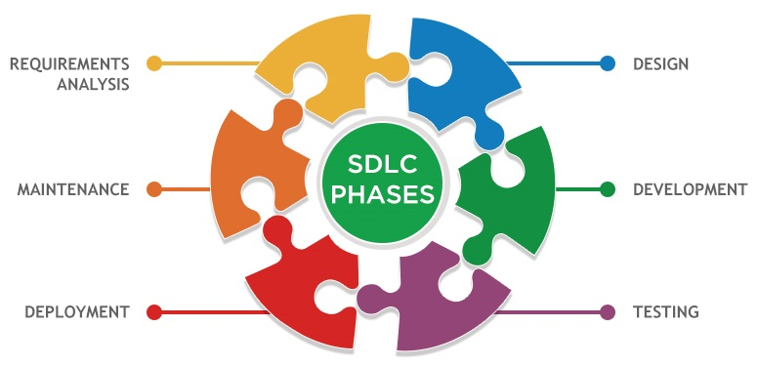

In order to develop the project “iSchool” we have adopted the Iterative Enhancement Model also known as Incremental Model. This model removes the shortcoming of waterfall model. Since many facts of this system are already known. It is not a new concept and hence no research is required. A working version can be easily created and hence the system can start working. Rest of the functionalities can be implemented in the next iteration and can be delivered later. As the requirement analysis is also not required. It not being a new technology risk involved is also less. So one need not perform detailed risk analysis. If redevelopment staff is less than development can be started with less number of people and in next increments others can be involved. As this model combines the advantage of waterfall model and prototyping, clients are always aware of the product being delivered and can always suggest changes and enhancements and can get them implemented. As less amount of customer communication is required one need not apply spiral model in which all types of analysis is done in detail. As the deadline is affordable one need not to for Rapid Application Development model. Iterative enhancement model is useful when less manpower is available for software development and the release deadlines are specified. It is best suited for in house product development, where it is ensured that the user has something to start with. The complete product is divided into releases and the developer delivers the product release by release.

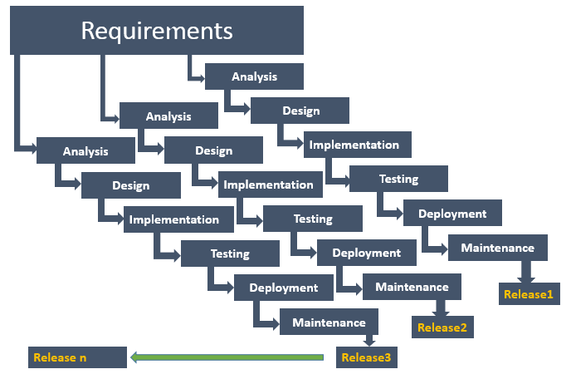
Incremental Model
2.3 Data Flow Diagram (DFD)

Data flow diagram is graphical representation of flow of data in an information system. It uses defined symbols like rectangles, circles and arrows, plus short text labels, to show data inputs, outputs, storage points and the routes between each destination. Data flowcharts can range from simple, even hand-drawn process overviews, to in-depth, multi-level DFDs that dig progressively deeper into how the data is handled.

2.3.1 DFD 0 Level
The 0 Level DFD shows flow of data of application. DFD Level 0 is also called a Context Diagram. It’s a basic overview of the whole system or process being analyzed or modeled.

Buy Course
Upload Course
Student/Learner
Admin/Educator
iSchool
(E-Learning Managment System)
Report
Watch Course
O Level DFD

2.3.2 DFD 1 Level
DFD Level 1 provides a more detailed breakout of pieces of the Context Level Diagram. This DFD describes main functions carried out by the system, as we break down the high-level process of the Context Diagram into its sub-processes.
retrieve
Authentic Status
feedback
update
submit
update
update
view
retrieve
retrieve
retrieve
update
lesson
course
student
Admin/Student
Update profile
Update lesson
Upload course
Logout
Admin
Authentic
Authentic Status
Authentic Status
Authentic Status
Authentic Status
feedback
Student
Sell course
Authentic Status
courseorder
Report
Watch course
1 Level DFD
2.3.3 DFD 2 Level
The DFD 2 Level describes flow of data in more detail. DFD Level 2 goes one step deeper into parts of Level 1. It may require more text to reach the necessary level of detail about the system’s functioning.
Authentic Status
Check Authentication
Upload course
success
Modify or Remove Course
update
Add, Remove, Edit
course

Authentic Status
Modify or Remove Lesson
Check Authentication

Update Lesson
Add, Remove, Edit
success
Save data
lesson

2.4 Entity Relationship Diagram (ER-Diagram)
An Entity Relationship Diagram (ERD) is a visual representation of different entities within a system and how they relate to each other. Entity relationship diagrams are used in software engineering during the planning stages of the software project. They help to identify different system elements and their relationships with each other.

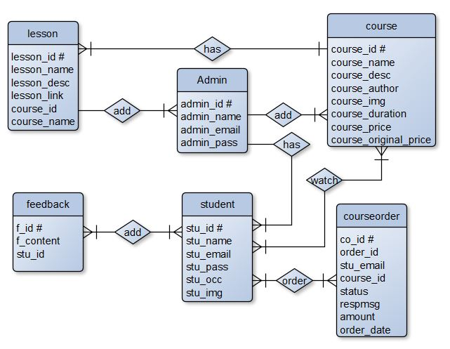

ERD
2.5 Flow Chart
A flowchart is a diagram that depicts a process, system or computer algorithm. They are widely used in multiple fields to document, study, plan, improve and communicate often complex processes in clear, easy-to-understand diagrams. Flowcharts, sometimes spelled as flow charts, use rectangles, ovals, diamonds and potentially numerous other shapes to define the type of step, along with connecting arrows to define flow and sequence.
Login
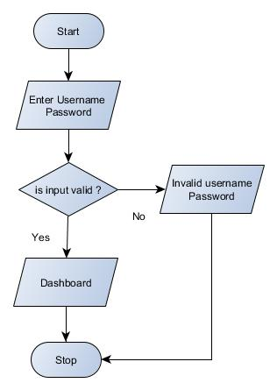

Add Lesson
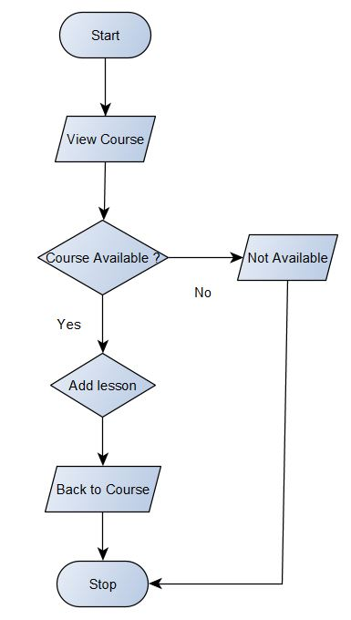

Payment Status
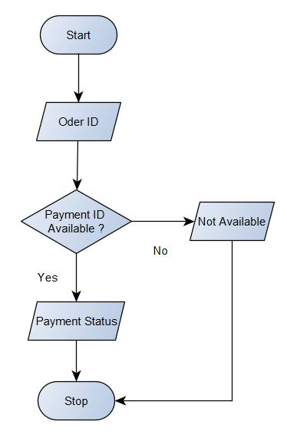
2.6 Gantt Chart
Gantt chart was invented by a mechanical engineer named Henry Gantt in 1910. A gantt chart is simply a type of bar chart that visually represents a project plan over time. It shows start and end dates for tasks, displays milestones, and allows for dependencies between tasks. With all the features of Henry gantt’s project management system, it’s no wonder that even now, more than 100 years later, the gantt chart is still the preferred tool for managing projects of all sizes and types.
Week | 1 | 2 | 3 | 4 | 5 | 6 | 7 | 8 | 9 | 10 | 11 | 12
Activities
Research
Define Specification
Project Planning
Design
Development
Test Plan
Testing and Q A
Delivery

2.7 Class Diagram
Class diagrams are the main building block in object-oriented modeling. They are used to show the different objects in a system, their attributes, their operations and the relationships among them.
Classes in class diagrams are represented by boxes that are partitioned into three:-
- The top partition contains the name of the class.
- The middle part contains the class’s attributes.
- The bottom partition shows the possible operations that are associated with the class.
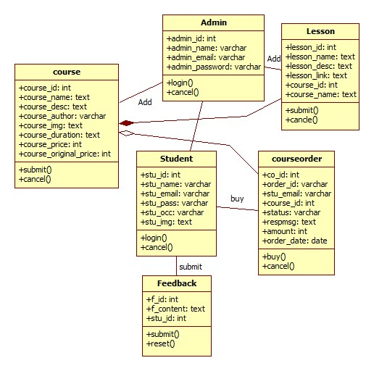

- System Design
The systems design approach first appeared right before World War II, when engineers were trying to solve complex control and communications problems. They needed to be able to standardize their work into a formal discipline with proper methods, especially for new fields like information theory, operations research and computer science in general. System design is the process of defining the elements of a system such as the architecture, modules and components, the different interfaces of those components and the data that goes through that system. It is meant to satisfy specific needs and requirements of a business or organization through the engineering of a coherent and well-running system.
3.1 Input Module
In order to complete the tasks of iSchool and to get output by using this application work, there is need of some input based on the work that is to be carried out by using it. Different kinds of input are required for different purposes.
- Student/Learner Registration
- Course
- Lesson
- Feedback
- Payment Status

3.2 Output Module
The project named “iSchool E-Learning Management System” is being made keeping in mind to solve the activities that are carried out in the Education. By using this, Admin can easily do many things like as:
- Student/Learner List
- Course Detail
- Lesson Detail
- Sell Report
- Payment Receipt

3.3 Modularization Detail
Without Registration
- Home – This module contains all the links of the application such as Courses, Payment Status, Login, Sign Up, Feedback Section and Contact.
- Courses – This module contains list of all the courses which are available at iSchool.
- Payment Status – This module is used to check Payment status after purchasing a course.
- Login – This module is used to login into Student/Learner Panel.
- Sign Up – This module is used to register for the Student/Learner Panel.
- Feedback – This section shows feedback given by registered students/learners.
- Contact – Learner can use this section to contact the admin/tutor for any kind of queries.

Student Panel
- Profile – This module contains all the details about Student/Learner as well as Student can update their details.
- My Courses – This module contains list of all purchased courses.
- Feedback – This module is used to write feedback.
- Change Password – Students can use this module to change password.
- Logout – This module is used to return back to Home Page.

Admin Panel
- Dashboard – This module displays overview of whole application.
- Courses – This module contains all the courses.
- Lessons – This module contains all the lesson depends on course id.
- Students – This module displays all the registered student details.
- Sell Report – This module is used to view and print sells report.
- Payment Status – This module displays payment status in more details.
- Feedback – This module displays feedback given by students.
- Change Password – Admin can use this module to change password.
- Logout – This module is used to return back to Home Page.

3.4 Process Logic
Home:
When the user click on this tab, it will display the other modules and pages of the website such as courses, payment status, login, sign up, popular section, feedback section, contact and admin login. This module will be used to display the brief introduction of the project and will show the title of the project.

Courses:
Student can view all available courses by clicking on courses tab where he can choose course according to his own interest and by clicking on a particular course, will display more details with lesson title of the course, if he wants to purchase he will be able to make payment (required login).
Payment Status:
After purchasing course student will be provided an order id which can be used to get the status of payment using Payment status tab. If student wants he can get print out of his payment status.
Login:
This is a login form. Student/Learner can use their own email and password to login into the student panel.
Sign Up:
This is a Registration form for new Students/Learners. New Students/Learners can fill up the form for registration and after successful registration they can use their email id and password to login into the application.
Feedback:
This is very simple section which displays feedback given by the registered student.
Contact:
Learner can use this section to contact the admin/tutor for any kind of queries.

Student Panel:-
Profile:
Students/Learners can view their student id, registered email id, name, occupation, profile picture as well as they can modify and update the new data if they need.
My Courses:
Students can view all courses which they purchased. This is the place where they can start watching lectures by clicking on Watch Course button which leads to course playlist where they can watch the entire lesson of course.
Feedback:
Students can view/write feedback.
Change Password:
Students can use this module to change password.
Logout:
This module is used exit student panel and return back to Home Page.

Admin Panel
Dashboard:
This module displays overview of whole application such as number of course, number of registered students etc.
Courses:
This is the most important module of admin panel where Admin can view list of course as well as add new courses and modify or delete courses.
Lessons:
Admin can view lesson based on course id as well as new lesson can be added to the course and modification or deletion is also possible using this module.
Students:
Admin can view registered students details. Admin can add, edit and delete student.
Feedback:
Admin can view/delete feedback given by student.
Sell Report:
Analyzing sales is very import for any kind of business and this module is perfect for analyzing sales based on date. It will generate sells report which can be possible to print out for office records.
Payment Status:
If student file any complaints regarding payment Admin can use this module to display payment status in more details such as bank name, transaction id, payment date etc.
Change Password:
Admin can use change password.
Logout:
This module is used exit admin panel and return back to Home Page.

3.5 Data Integrity
Data integrity is the overall completeness, accuracy and consistency of data. This can be indicated by the absence of alteration between two instances or between two updates of a data record, meaning data is intact and unchanged. Data integrity is usually imposed during the database design phase through the use of standard procedures and rules. The concept of data integrity ensures that all data in a database can be traced and connected to other data. This ensures that everything is recoverable and searchable. Having a single, well-defined and well-controlled data integrity system increases stability, performance, reusability and maintainability. Data values are standardized according to a data model and data type. All characteristics of the data must be correct including business rules, relations, dates and definitions for data to be complete. Data integrity is imposed within a database when it is designed and is authenticated through the ongoing use of error checking and validation routines. As a simple example, to maintain data integrity numeric columns/cells should not accept alphabetic data.

3.6 Data Dictionary
A data dictionary contains a list of all files in the database, the number of records in each file, and the names and types of each field. Most database management systems keep the data dictionary hidden from users to prevent them from accidentally destroying its contents. For most relational database management systems (RDBMS), the database management system software needs the data dictionary to access the data within a database. For example, the MySQL Database software has to read and write to an MySQL Database. However, it can only do this via the data dictionary created for that particular database.

Table Name: Admin (Stores Admin Detail)
Attribute | Data Type | Description
admin_id # | int(11) | Stores Admin ID
admin_name | varchar(255) | Stores Admin Name
admin_email | varchar(255) | Stores Admin Email ID
admin_pass | varchar(255) | Stores Admin Password

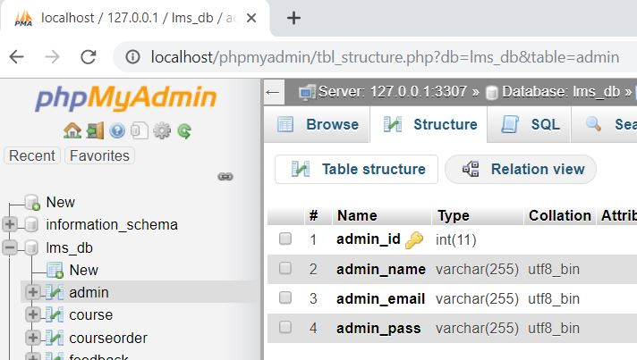

Table Name: Student (Stores Student Detail)
Attribute | Data Type | Description
stu_id # | int(11) | Stores student ID
stu_name | varchar(255) | Stores student Name
stu_email | varchar(255) | Stores student Email ID
stu_pass | varchar(255) | Stores student Password
stu_occ | varchar(255) | Stores student occupation
stu_img | text | Stores student profile picture

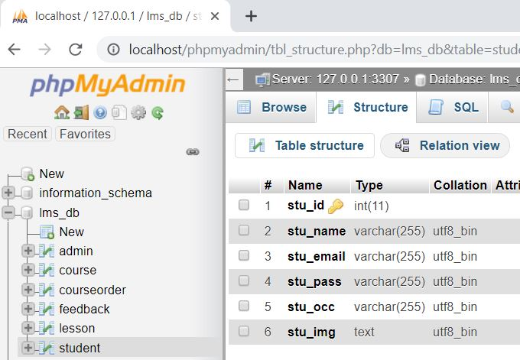

Table Name: Feedback (Stores Feedback Detail)
Attribute | Data Type | Description
f_id # | int(11) | Stores Feedback ID
f_content | text | Stores Feedback content
stu_id | int(11) | Stores Student ID

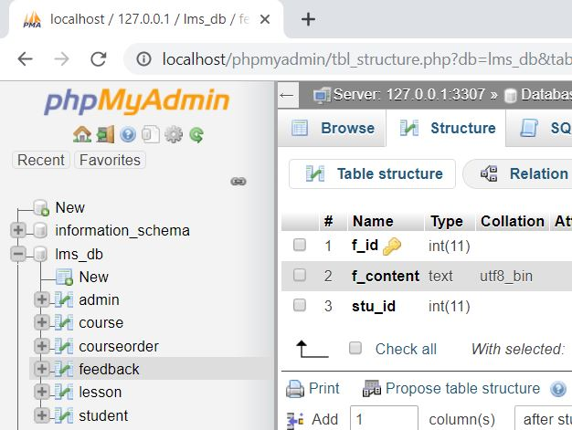

Table Name: course (Stores Course Detail)
Attribute | Data Type | Description
course_id # | int(11) | Stores Course ID
course_name | text | Stores course Name
course_desc | text | Stores course description
course_author | varchar(255) | Stores course author/instructor
course_img | text | Stores course display picture
course_duration | text | Stores course duration
course_price | int(11) | Stores course selling price
course_original_price | int(11) | Stores course original price

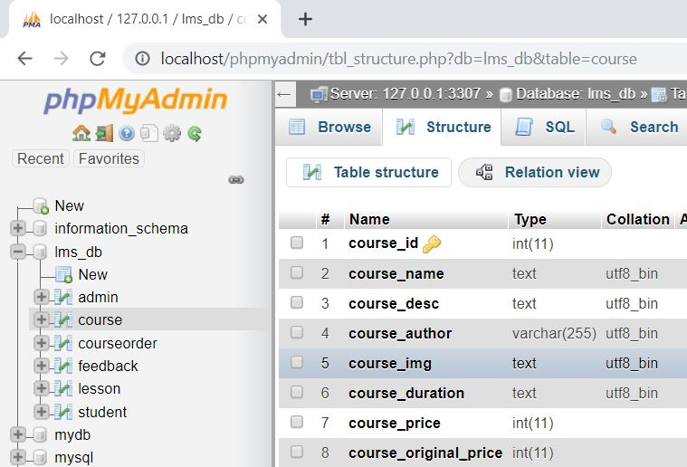

Table Name: Lesson (Stores Lesson Detail)
Attribute | Data Type | Description
lesson_id # | int(11) | Stores Lesson ID
lesson_name | text | Stores Lesson name
lesson_desc | text | Stores lesson description
lesson_link | text | Stores lesson video link/video file
course_id | int(11) | Stores course ID
course_name | text | Stores course Name

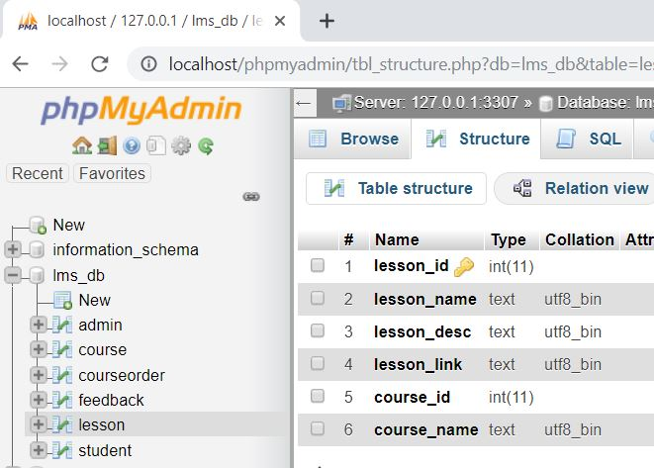

Table Name: courseorder (Stores Course order Detail)
Attribute | Data Type | Description
co_id # | int(11) | Stores course order ID
order_id | varchar(255) | Stores Order ID (Random)
stu_email | varchar(255) | Stores student email id
course_id | int(11) | Stores course id
status | varchar(255) | Stores payment status
respmsg | text | Stores payment response msg
amount | int(11) | Stores course amount
order_date | date | Stores purchase date

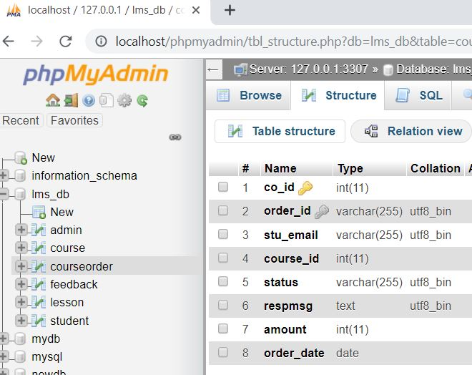

3.7 User Interface Design
User interface design is concerned with the dialogue between a user and the computer. It is concerned with everything from starting the system or logging into the system to the eventually presentation of desired inputs and outputs. The overall flow of screens and messages is called a dialogue.
- It should be attractive and simple to use.
- The system user should always be aware of what to do next.
- Messages, instruction and information should be displayed long enough to allow the system user to read them.
- An user should not be allowed to proceed without correcting an error.
- An user should never get an fatal error instead provide them understanble errors.

- Tools and Environment

4.1 Hardware Requirements
Processor | 1.6 GHz or Faster Processor
RAM | 4 GB
Disk Space | 10 GB of Available Hard Disk
Graphic | DirectX 9-Capable Video Card
Display | 1024 X 768 or Higher Resolution

4.2 Software Requirements
Operating System | Windows 10
Front End | HTML, CSS, JavaScript
Back End | PHP
Library/ Framework | Bootstrap, JQuery, FontAwesome
Plugins  Code Editor | Owl Carousel
 | Visual Studio Code 1.33
Database | MySQL
Web Server | Apache
Web Browser | Google Chrome
Payment Gateway | Paypal
Drawing Tools | yEd Graph Editor
 | StarUML

- Testing

Software testing is a process used to identify the correctness, completeness and quality of developed computer software. It includes a set of activities conducted with the intent of finding errors in software so that it could be corrected before the product is released to the end users. In other word software testing is an activity to check that the software system is defect free.
Software testing is primarily a broad process that is composed of several interlinked processes. The primary objective of software testing is to measure software health along with its completeness in terms of core requirements. Software testing involves examining and checking software through different testing processes.
The objectives of these processes can include:
- Completeness - Verifying software completeness in regards to functional/business requirements
- Errors Free - Identifying technical bugs/errors and ensuring the software is error-free
- Stability - Assessing usability, performance, security, localization, compatibility and installation

This phase determine the error in the project. If there is any error then it must be removed before delivery of the project.

7.1 Type of Testing

For determining errors various types of test action are performed: -
Unit Testing: - Unit testing focuses verification effort on the smallest unit of software design – the module. Using the detail design description as a guide, important control paths are tested to uncover errors within the boundary of the module. The relative complexity of tests and the errors detected as a result is limited by the constrained scope established for unit testing. The unit test is always white box oriented, and the step can be conducted in parallel for multiple modules.
Unit testing is normally considered an adjunct to the coding step. After source level code has been developed, reviewed, and verified for correct syntax, unit test case design begins.

Integration Testing - A level of the software testing process where individual units are combined and tested as a group. The purpose of this level of testing is to expose faults in the interaction between integrated units.

System Testing: - Software is only one element of a larger computer based system. Ultimately, software is incorporated with other system elements (e.g. new hardware, information), and a series of system integration and validation tests are conducted. Steps taken during software design and testing can greatly improve the probability of successful software integration in the larger system.
A classics system testing problem is “finger pointing”. This occurs when a defect is uncovered, and one system element developer blames another for the problem. The software engineer should anticipate potential interfacing problems and design error handling paths that test all information coming from other elements of the system, conduct a series of tests that simulate bad data or other potential errors at the software interface, record the results or tests to use as “evidence” if finger pointing does occur, participate in the planning and design of system test to ensure that software is adequately tested.

There are many types of system tests that are worthwhile for software-based systems:-

Usability Testing - Usability Testing is a type of testing done from an end-user’s perspective to determine if the system is easily usable.

Functionality Testing - Tests all functionalities of the software against the requirement.

Performance Testing – Performance testing is designed to test the run-time performance of software within the context of an integrated system.

Security Testing – Security testing attempts to verify that protection mechanisms built into a system will protect it from improper penetration.

Stress Tests – Stress tests are designed to confront programs with abnormal situations.

7.2 Use Case

A use case diagram is essentially a picture showing system behavior along with the key actors that interact with the system. The use case represents complete functionality. Use case diagram can be imagined as a black box where only the input, output, and the function of the black box are known. Use Case elements are used to make test cases when performing the testing. The use case should contain all system activities that have significance to the users. A use case can be thought of as a collection of possible scenarios related to a particular goal, indeed. Use cases can be employed during several stages of software development, such as planning system requirements, validating design and testing software.
Use case Diagram Objects
Use case diagrams mostly consist of 3 objects: -
Actor - Actor is a use case diagram is any entity that performs a role in one given system. This could be a person, organization or an external system.
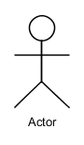

Use Case - A Use case represents a function or an action within the system. its drawn as an oval and named with the function.
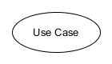

System - System is used to define the scope of the use case and drawn as rectangle.
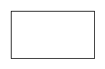

There are two functions: -
Include – This represents required. Symbol of this function is dashed arrow and arrow is labeled with the keyword <<include>>

Extend – This represents optional and it is also shown with dashed arrow the arrow is labeled with the keyword <<extend>>

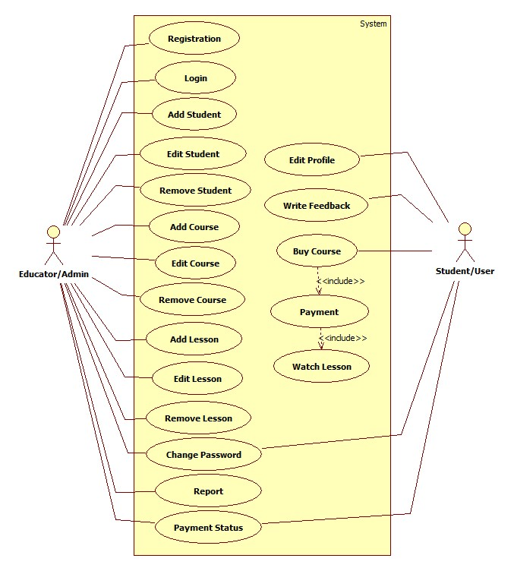

Use Case

7.3 Test Case
A test case is a set of conditions or variables under which a tester will determine whether an application, software system or one of its features is working as it was originally established for it to do.

Login:
Test Case ID | Test Scenario | Test Case | Pre-Condition | Test Steps | Test Data | Expected Result | Actual Result | Status  Pass/Fail
TC_Login_1 | Verify Login | Enter Valid username and valid password | Need a valid username and password to do login | 1. Enter username  2. Enter Password  3. Click Login | Valid username  Valid password | Successful login, Main screen of application should displayed | Successful login, Main screen of application displayed | Pass
TC_Login_2 | Verify Login | Enter Valid username and invalid password | Need a valid username and password to do login | 1. Enter username  2. Enter Password  3. Click Login | Valid username  Invalid Password | No Matched Username/ Password | No Matched Username/ Password | Pass
TC_Login_3 | Verify Login | Enter Invalid username and valid password | Need a valid username and password to do login | 1. Enter username  2. Enter Password  3. Click Login | Invalid username  Valid Password | No Matched Username/ Password | No Matched Username/ Password | Pass
TC_Login_4 | Verify Login | Enter Invalid username and invalid password | Need a valid username and password to do login | 1. Enter username  2. Enter Password  3. Click Login | Invalid username  Invalid Password | No Matched Username/ Password | No Matched Username/ Password | Pass

User/Student Registration
Test Case ID | Test Scenario | Test Case | Pre-Condition | Test Steps | Test Data | Expected Result | Actual Result | Status  Pass/Fail
TC_SREG_1 | Verify User Registration Detail | Enter valid name, email, new password | Need valid Data to be entered | 1. Enter name  2. Enter email  3. Enter Password  4. Click Sign up | Valid name, valid email, valid password | Successful, User Added Successfully | Successful, User Added Successfully | Pass
TC_SREG_2 | Verify Staff Registration Detail | Enter name, already registered email, new password | Need Data to be entered | 1. Enter name  2. Enter Email  3. Enter Password  4. Click Sign up | Valid name, already registered email, valid password | Email ID Already Registered | Email ID Already Registered | Pass
TC_SREG_3 | Verify Staff Registration Detail | Entering Nothing, Required Fields are blank | - | Click Sign up | Nothing to enter Required fields are blank | Fill required field | Fill required field | Pass
Add Course
Test Case ID | Test Scenario | Test Case | Pre-Condition | Test Steps | Test Data | Expected Result | Actual Result | Status  Pass/Fail
TC_Course_1 | Verify Course Detail | Enter Valid and correct data | Need valid text and number Data to be entered | 1. Enter Valid Data in appropriate fields  2. Click Submit | Valid Text and Number Data | Successful, Course Added Successfully | Successful, Course Added Successfully | Pass
TC_Course_2 | Verify Course Detail | Enter invalid and incorrect data | Need text and number Data to be entered | Enter invalid Data in fields | Invalid Text and Number Data | Enter Valid Data | Enter Valid Data | Pass
TC_Course_3 | Verify Course Detail | Entering Nothing, Required Fields are blank | - | Click Submit | Nothing to enter Required fields are blank | Fill required field | Fill required field | Pass

- Sanpshots
Home Page



• Displays overview of the iSchool platform.

• Provides navigation to courses, login, signup, and contact.

• Shows featured courses and user feedback.

Courses Page

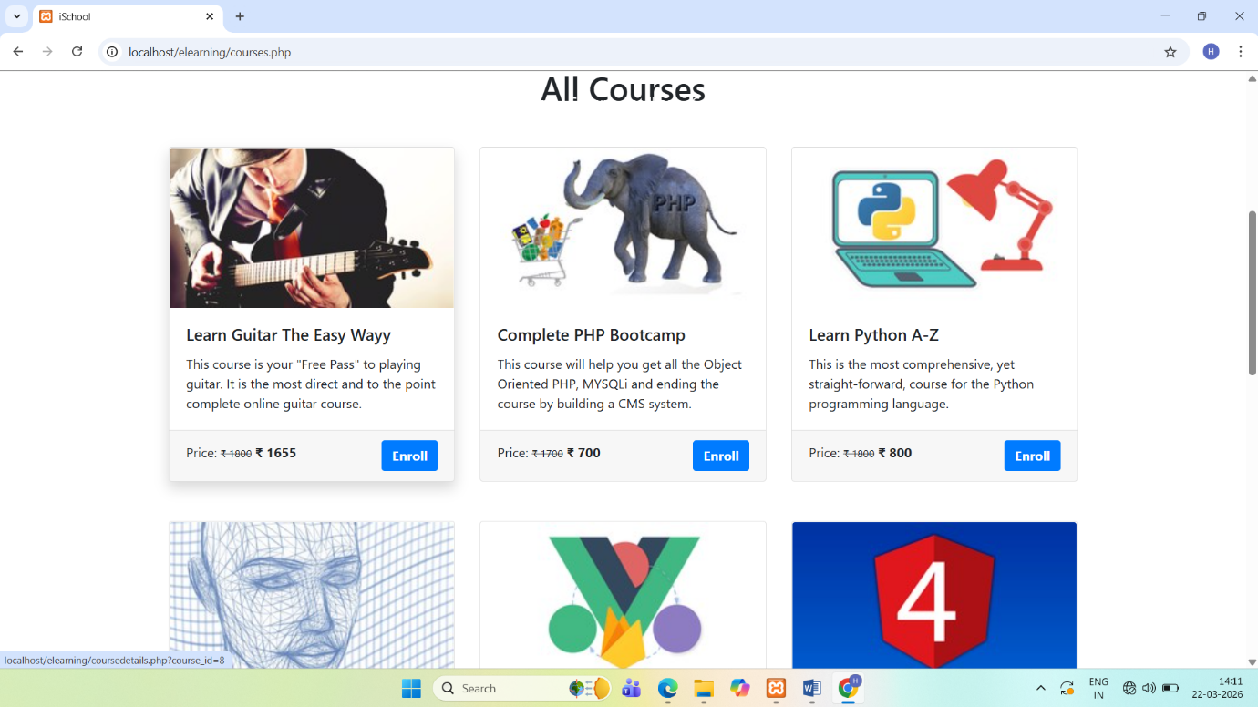

• Displays list of all available courses.

• Shows course details like title, price, and duration.

• Allows users to select and view course information.

Payment Status Page

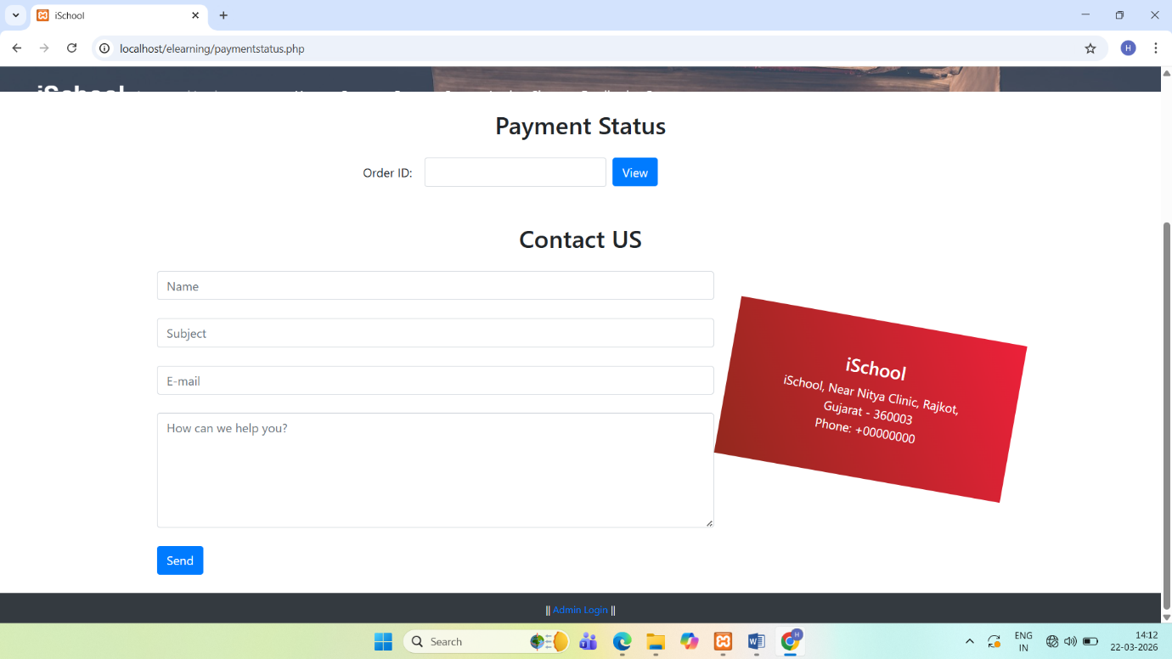
- Allows users to check payment status using Order ID.

- Displays transaction details and payment confirmation.

- Helps users verify successful purchase.

Signup Page

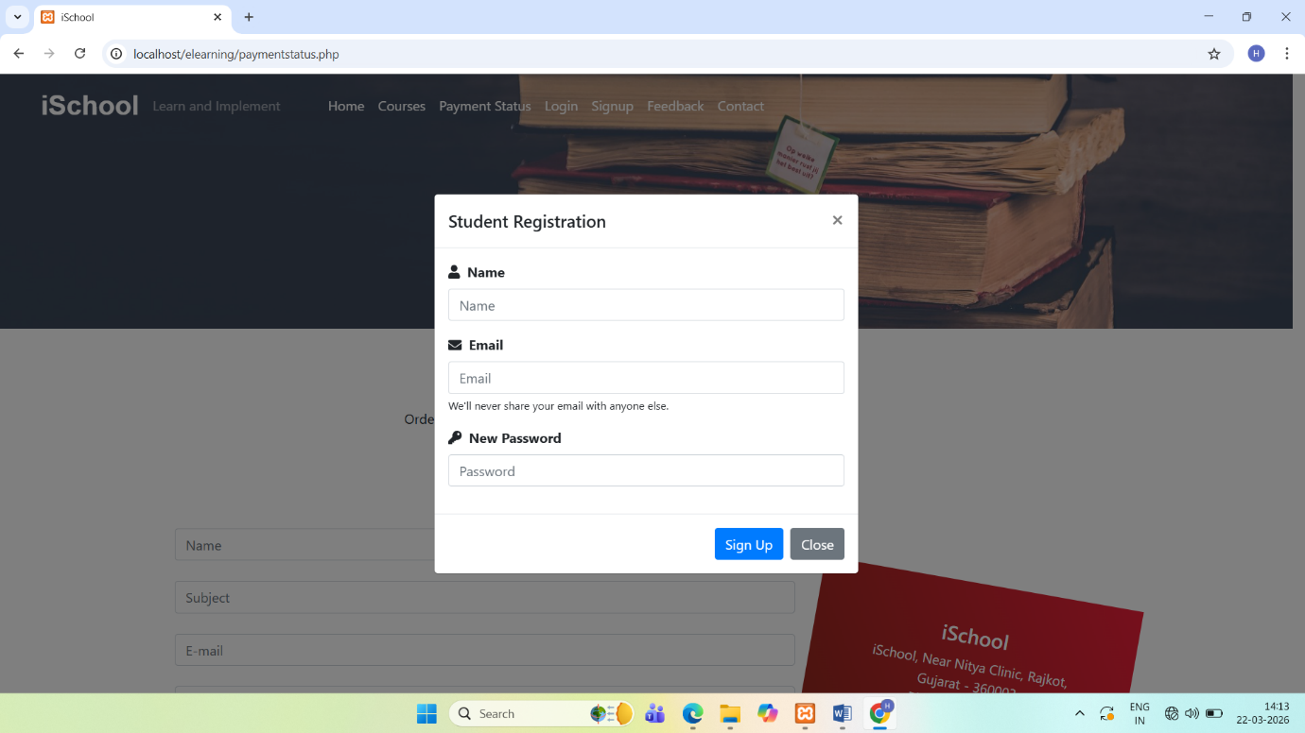

• New users can register by entering details.

• Collects name, email, and password.

• Creates user account for accessing system.
Login Page

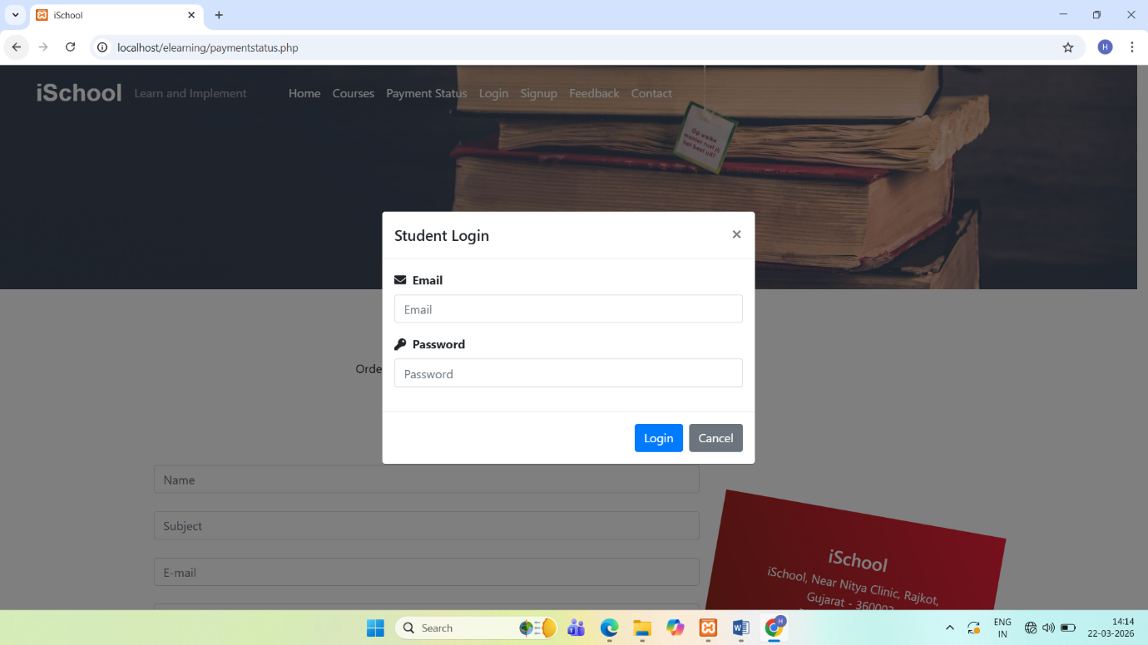

• Allows registered users to login.

• Authenticates user credentials.

• Redirects to user dashboard after login.
Feedback Page



- Displays feedback given by users.

- Helps improve system based on user suggestions.

- Shows user opinions about courses.

Contact Page



• Provides contact form for user queries.

• Allows users to send messages to admin.

• Displays contact details of admin.
User Profile Update Page

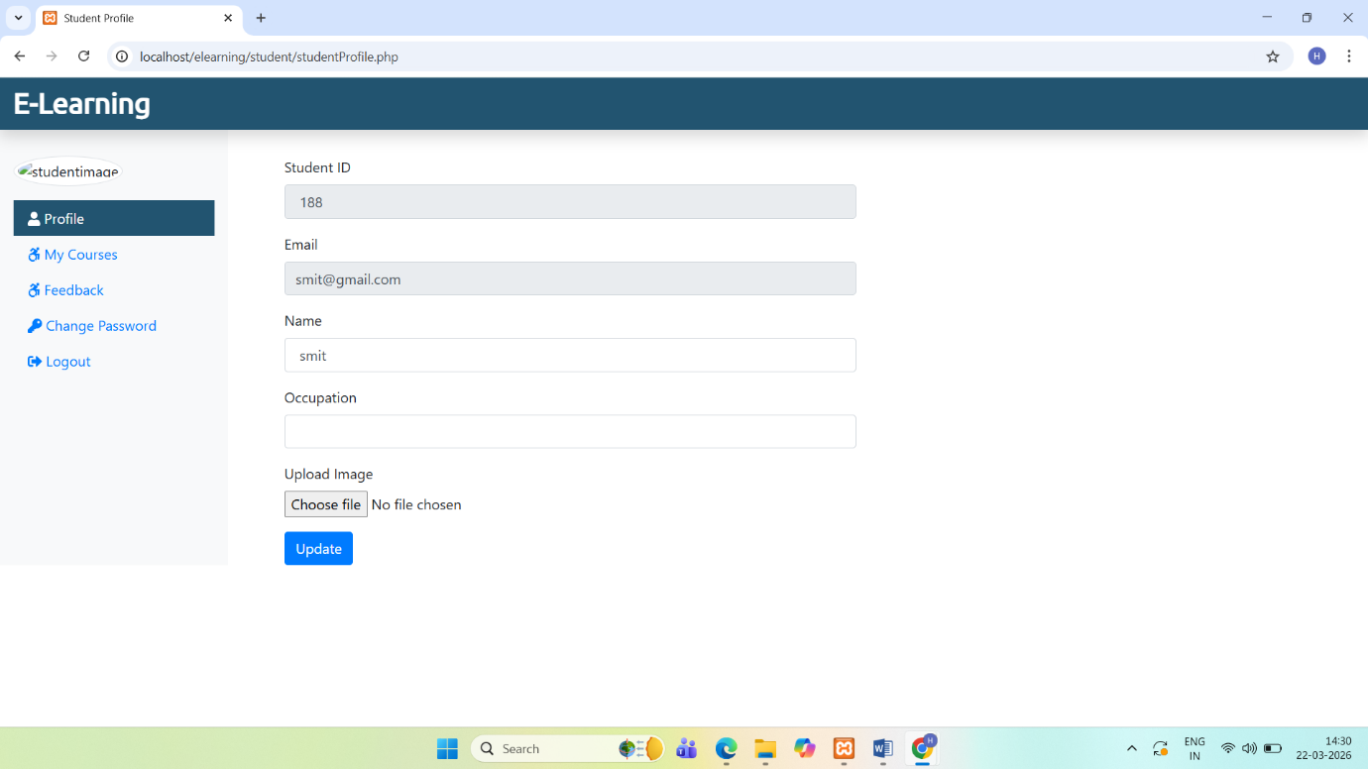

- Shows user personal details.

- Allows users to update profile information.

- Enables profile picture upload.

User Courses Page

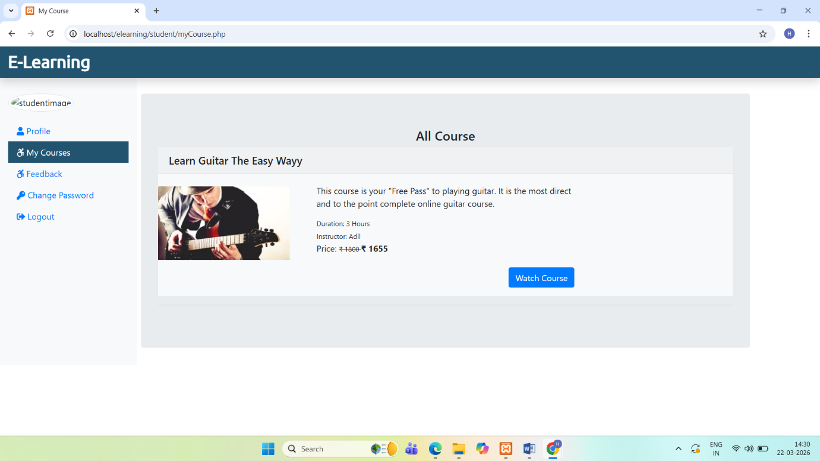

- Displays list of purchased courses.

- Allows users to watch course videos.

- Provides access to learning content.

Send Feedback Page

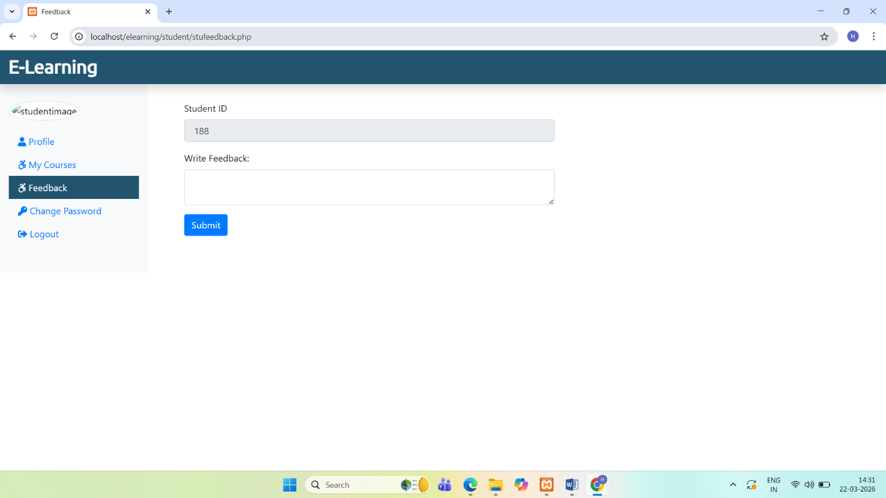

• Allows users to submit feedback.

• Helps improve course quality.

• Stores feedback in system database.
User Change Password Page

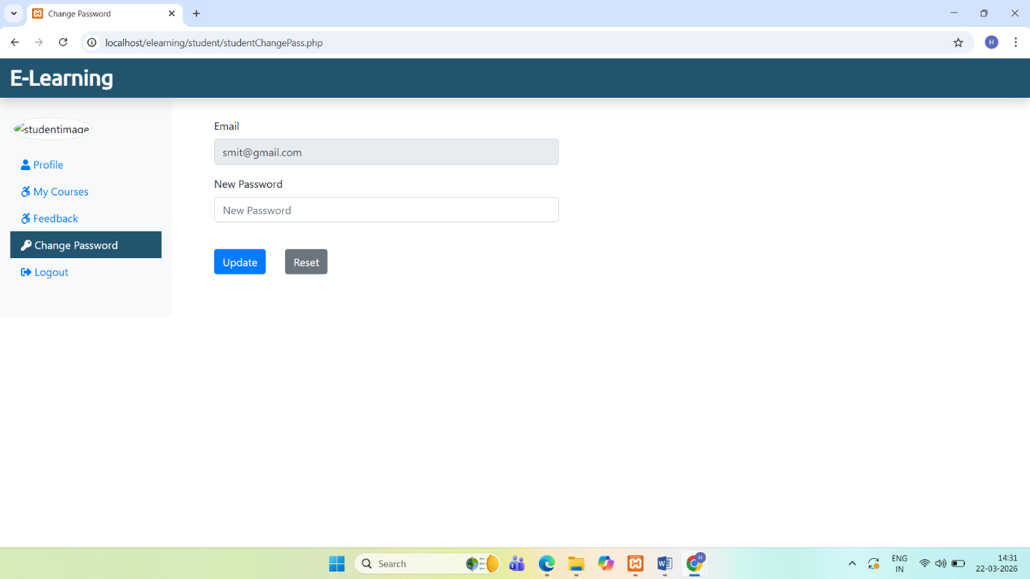

• Allows users to change their password.

• Ensures account security.

• Requires old and new password input.
Admin Login Page

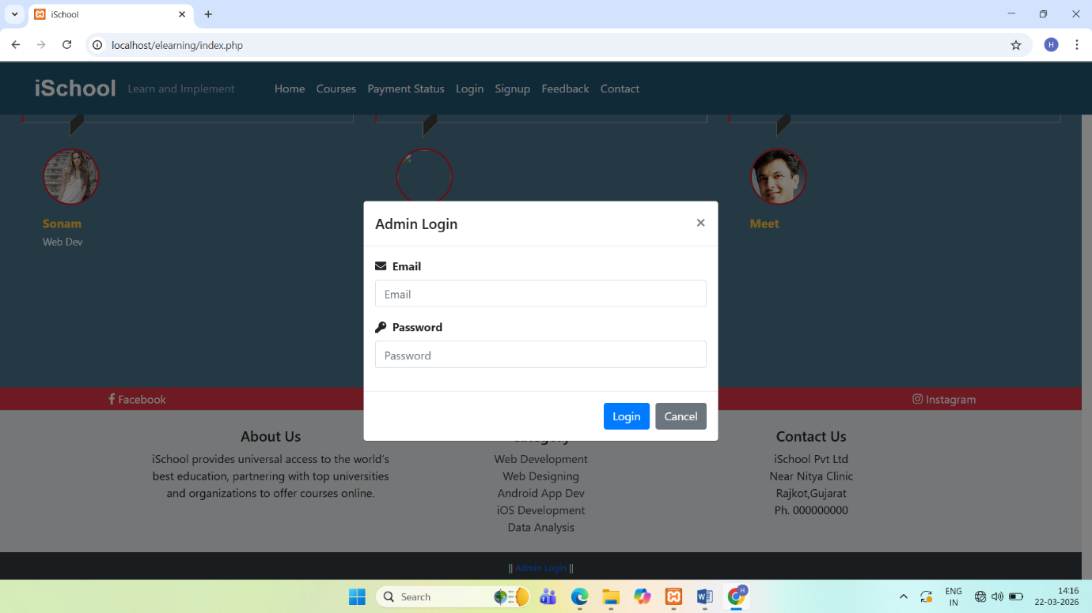

• Allows admin to login into system.

• Authenticates admin credentials.

• Provides secure access to admin panel.
Admin Dashboard

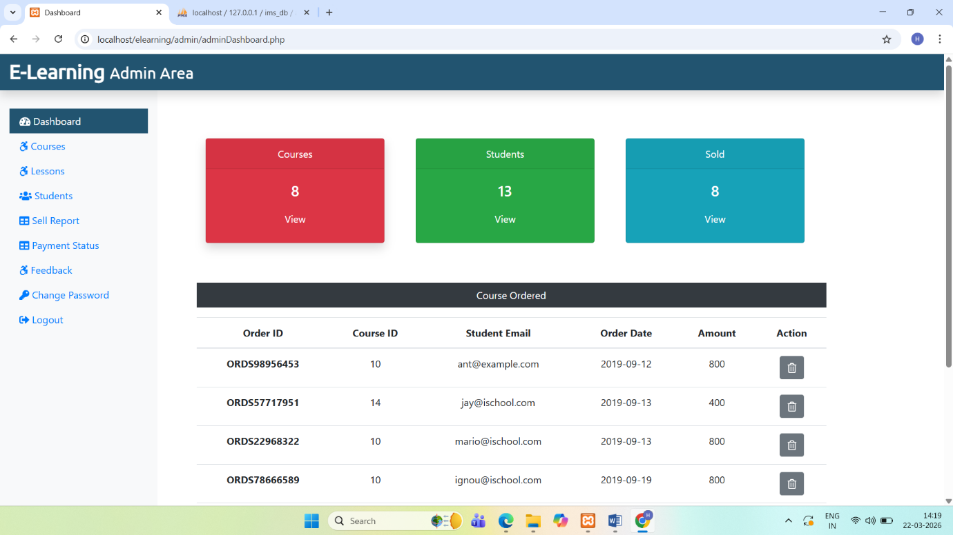

- Displays overview of system activities.

- Shows total courses, users, and sales.

- Provides quick access to admin modules..

Add Courses Page

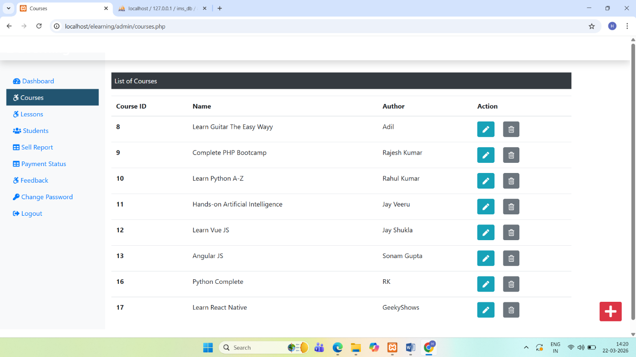

• Allows admin to add new courses.

• Includes course details like name, price, duration.

• Updates course list in system.
Add Lessons Page

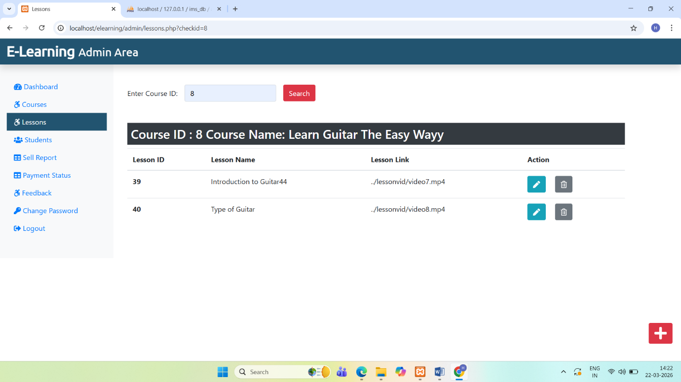

• Allows admin to add lessons to courses.

• Includes lesson title and video link.

• Organizes course content.
Students Page

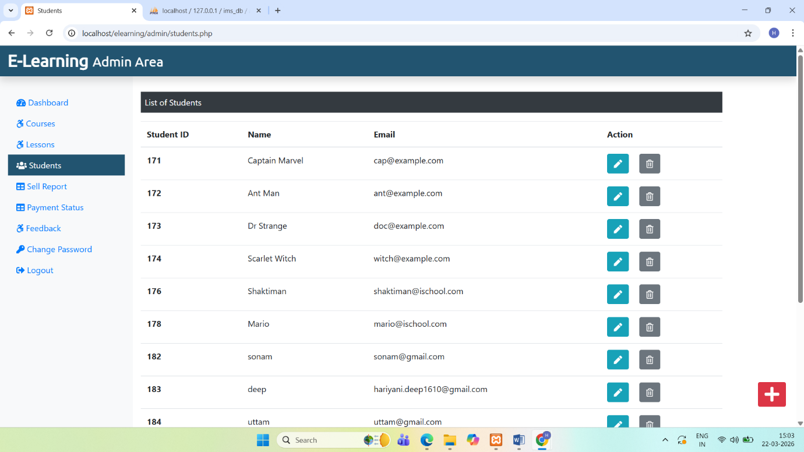

- Displays list of registered students.

- Allows admin to manage student details.

- Provides options to edit or delete users.

Sell Report Page

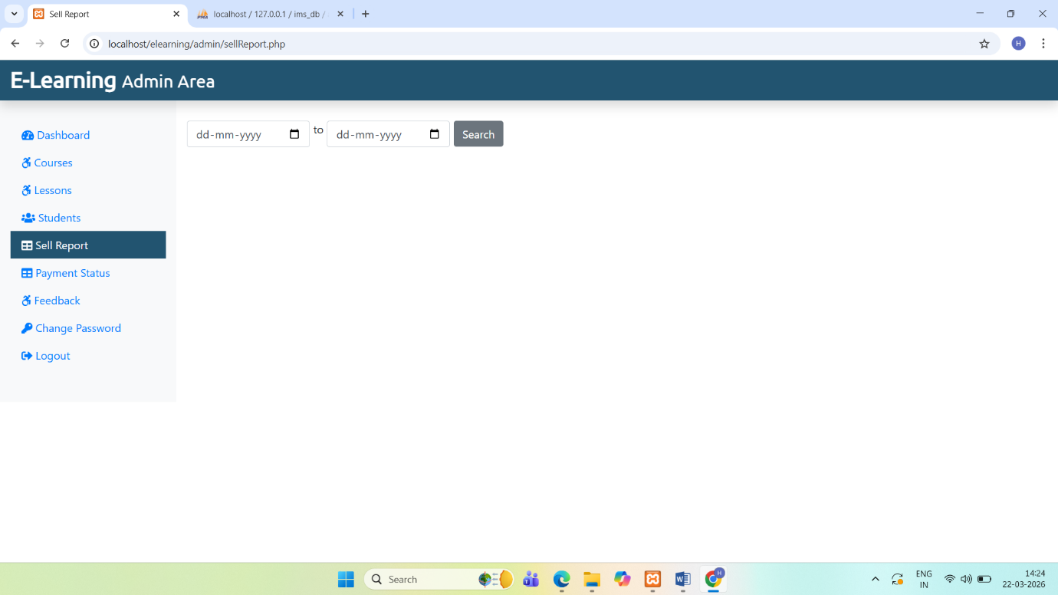

• Displays sales report of courses.

• Shows earnings based on date.

• Helps in business analysis.
Payment Status Page

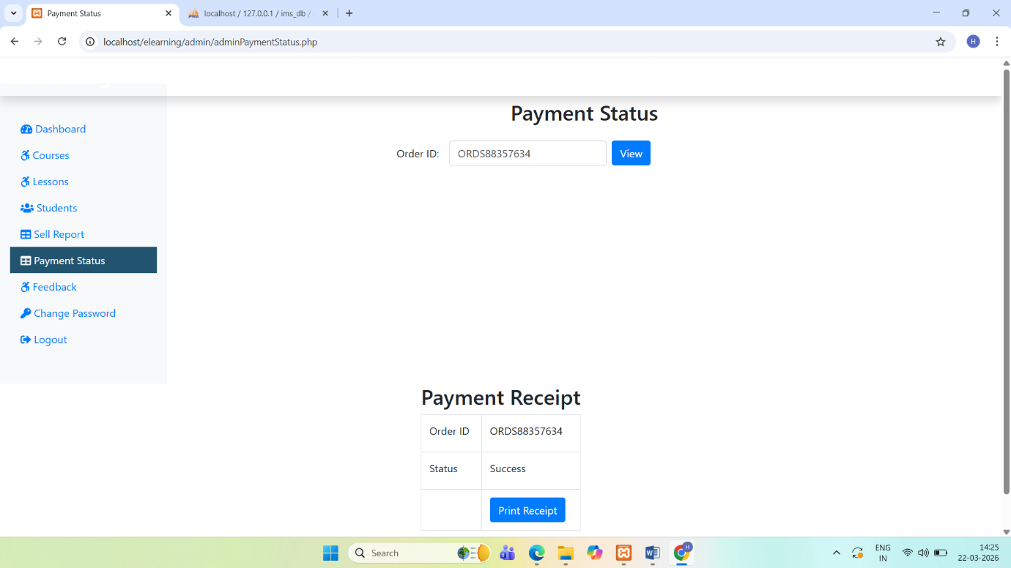

• Displays detailed payment information.

• Shows transaction ID and payment status.

• Helps resolve payment issues.
User Feedback Page

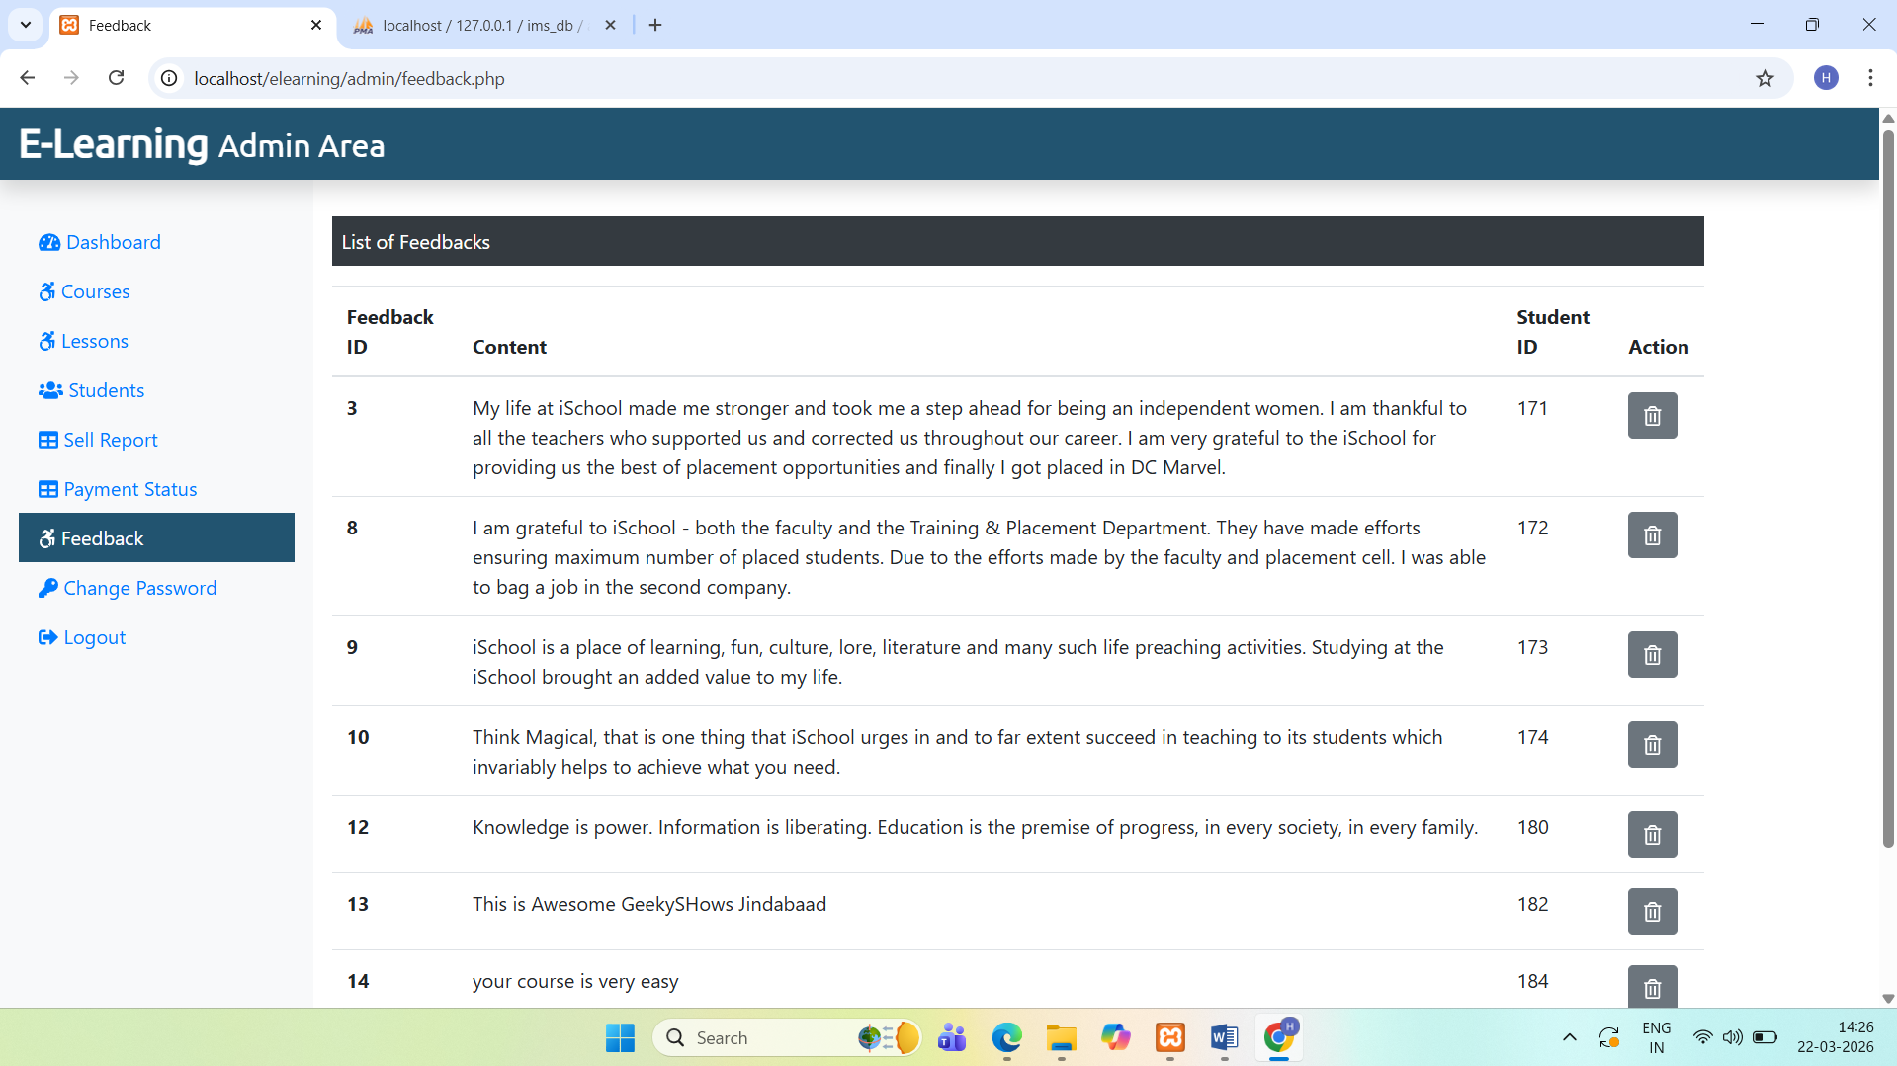

• Displays feedback submitted by users.

• Helps admin analyze user satisfaction.

• Allows admin to manage feedback.
Admin Password Change Page

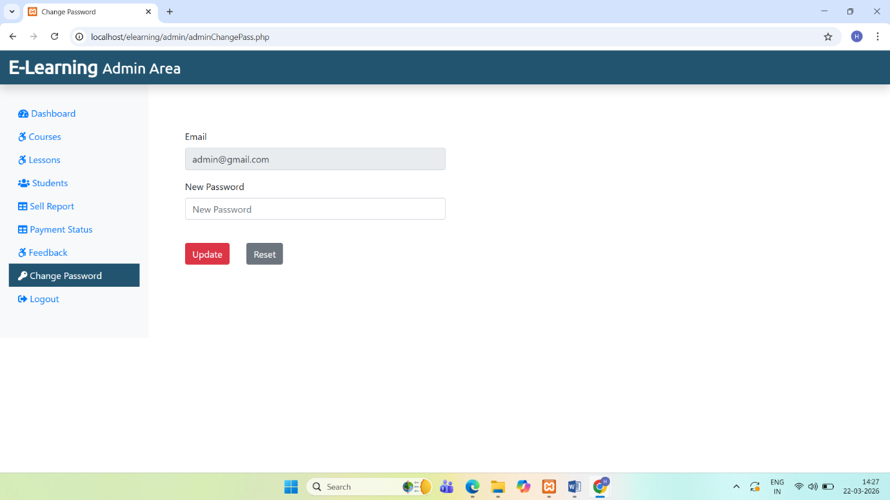

• Allows admin to update password.

• Improves system security.

• Requires old and new password.

- Implementation

Our dedication to our Clients goes well beyond the deployment of our Application. We are committed to providing our Client with a positive experience that starts with a successful implementation.
Implementation is the stage in the project where the theoretical design is turned into a working system. The implementation phase constructs, installs and operates the new system. The most stage is achieving a new successful system is that it will work efficiently and effectively.
Security and integrity of database are very important for any software system because databases are the backbone of the system. Security need to be implanted at every level of the system so that only authorized user can access the system for updation and other significance process.

- Limitation

- Only one tutor can access at a time
- It’s not SEO friendly
- Risk unauthorized accessibility
- Support is good in modern web browsers but not in legacy ones

- Future Scope

- More than one tutor can be added
- Interaction between Student and Tutor can be improved by introducing Discussion forum
- Quiz Facility may enhance this application’s market value
- Live Class can be added

- Conclusion
The iSchool E-Learning Maintenance Managment System has been computed successfully and was also tested successfully by taking "Test Cases". It is user friendly, and has required options, which can be utilized by the user to perform the desired operations.
The Software is developed using HTML, CSS, JS as front end and PHP, MySql as back end in windows environment.
The goals that are achieved by the software are:
- Simplification of the operations
- Less processing time and getting required information
- User friendly
- Portable and flexible for further enhancement

Bibliography
The following reference has been used to develop the project “iSchool” :-
Books: -
- IGNOU Blocks of Systems Analysis and Design
- IGNOU Blocks of Introduction to Software Engineering
- The Complete Reference PHP
- Head First SQL: Your Brain on SQL by Lynn Beighley
Web Source: -
- www.google.co.in
- www.wikipedia.org
- www.php.net
- www.stackoverflow.com
- www.getbootstrap.com
- www.fontawesome.com

